**How to Find Information in GCdocs**

**Content Filter**

This function allows you to filter through the items on your screen. You can narrow them based on the Name, the Document Type, the Content Type, the Owner, or the Modification Date.

1. To search a document by name, type the title that you are looking for in the Filter by name box.
2. To narrow the search, you may filter based on the document type, the content type, the owner, or the modification date of the item that you are looking for.
3. Once you have set the filters to your preference, click the magnifying glass to begin your search.

**Limited Functions Content Filter**

1. To begin the search, go to the location of the documents that you would like to filter through.
2. Type the name you are searching for in the Filter by name box.

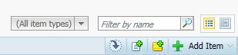

1. If you would like to filter the items by type (such as, documents, e-mails, e-mail folders, or shortcuts) click the drop-down menu to the left to display the different options.

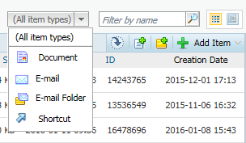

1. Press the magnifying glass button to perform the search and display your results.



**Open Text Office Editor**

Open Text Office Editor is an application that tracks the documents that you have downloaded and/or edited on your computer from external servers. In other words, this function allows you to view all of the items that you access through GCdocs.

1. Open the application from your tool bar

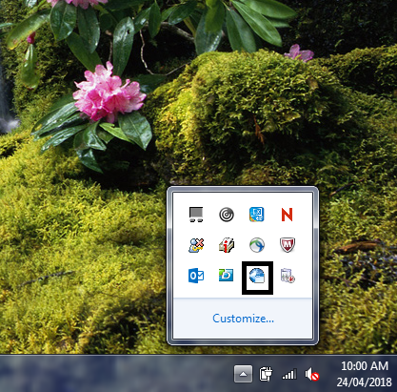

1. Click the drop down menu to display the different option

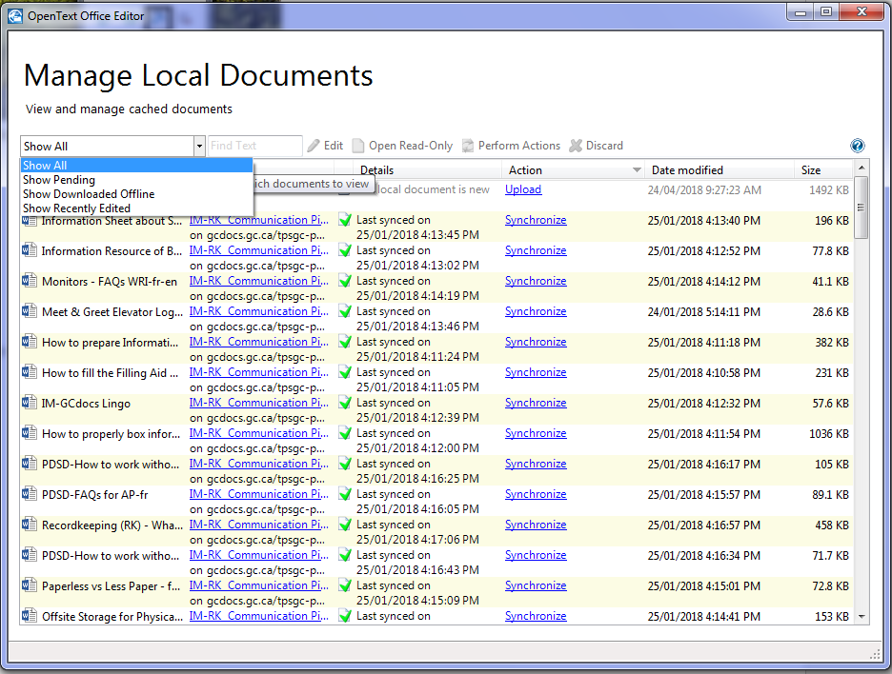

* 1. Show Pending shows the documents that you have accessed.
  2. Show Recently Edited shows documents that you have edited.
  3. Show Downloaded Offline shows documents downloaded when you were not connected.

1. You may organize the results on your screen by the different characteristics such as alphabetical order, the details of the document, the date modified, the size, etc.

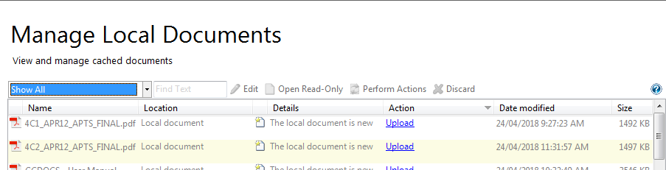

1. To search for an item by name, simply type the title in the Find Text box and hit enter to perform the search.

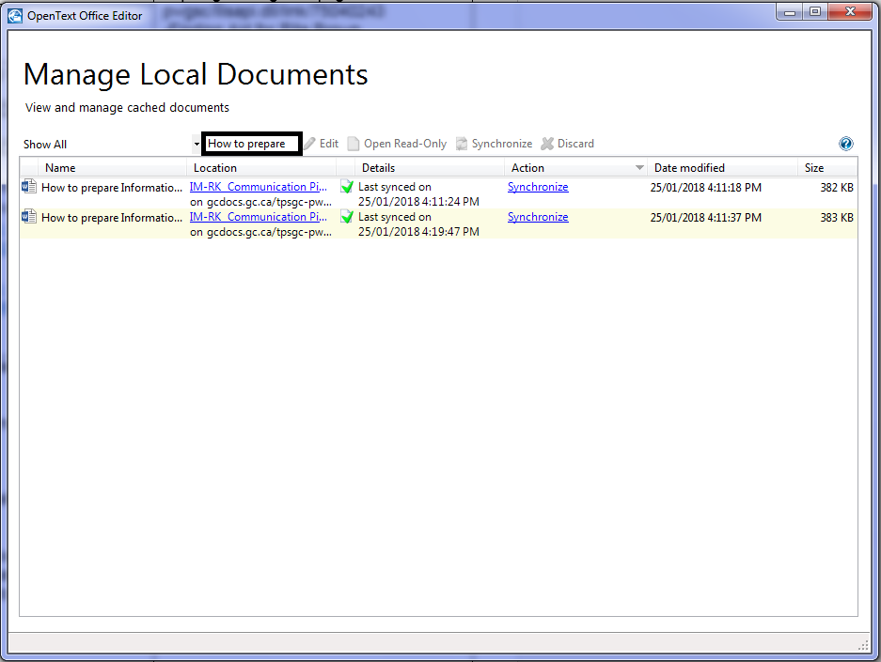

1. Once the screen shows you the different items that match your search, you may open them by clicking on their titles.